Department of Computer Science and Engineering
2024 CSE BATCH
23CSE463 – Quantum Computing

Agneay B Nair
CH.SC.U4CSE24102

WORKSHEET

WORKSHEET- 4
EX.NO : 4
DATE : 23/7/2026
TITLE : Study of Parameterized Rotation Gates (Rx, Ry, and Rz) Using PennyLane
AIM:
To design and simulate parameterized quantum circuits using Rotation-X (Rx), Rotation-Y (Ry), and Rotation-Z (Rz) gates in PennyLane, and study their influence on quantum state evolution, measurement probabilities, expectation values, and entanglement in single-qubit and multi-qubit quantum systems.
APPARATUS REQUIRED:
- Python 3.10 or above
- Qiskit Quantum Computing Framework
- Jupyter Notebook / Visual Studio Code (VS Code)
- Internet Connection (for package installation and documentation access)
- Quantum Computing Reference Material or Lab Manual

THEORY:
Quantum computing uses qubits as the fundamental unit of information. Unlike classical bits, which can only exist in one of two states (0 or 1), a qubit can exist in a superposition of both states simultaneously. A general single-qubit state is represented as
$∣ψ⟩=α∣0⟩+β∣1⟩$
where α and β are complex probability amplitudes satisfying
$$∣α∣+∣β∣2=1$$
The state of a qubit can be visualized on the Bloch Sphere, where every point on the sphere corresponds to a unique quantum state. Quantum gates manipulate qubits by performing rotations on the Bloch sphere. Among these gates, the Rotation-X (Rx), Rotation-Y (Ry), and Rotation-Z (Rz) gates are parameterized gates that rotate the quantum state about the X-, Y-, and Z-axes, respectively, by a specified angle θ. These gates are essential in quantum algorithms because they enable continuous transformations of quantum states rather than simple state flips.
The Rx gate rotates the qubit around the X-axis of the Bloch sphere by an angle θ. It changes both the amplitudes and phases of the quantum state and is mathematically represented as
$$Rx​\left(θ\right)=\left[\cos\left(\frac{θ}{2}\right)-isin\left(\frac{θ}{2}\right)​-isin\left(\frac{θ}{2}\right)\cos\left(\frac{θ}{2}\right)​\right]$$
When applied to the initial state $\left.∣0\right\rangle$, the resulting state becomes
$$Rx​(θ)∣0⟩=cos⁡(2θ​)∣0⟩-isin(2θ​)∣1⟩$$
The Ry gate rotates the qubit around the Y-axis. It produces real-valued amplitudes for the computational basis states and is widely used to generate superposition states. Its matrix form is
$Ry​\left(θ\right)=\left[\cos\left(\frac{θ}{2}\right)\sin\left(\frac{θ}{2}\right)​-\sin\left(\frac{θ}{2}\right)\cos\left(\frac{θ}{2}\right)​\right]$
Applying the Ry gate to the initial state gives
$$\left.\left.\left.R_{y}\left(θ\right)∣0\right\rangle =\cos\left(\frac{θ}{2}\right)∣0\right\rangle +\sin\left(\frac{θ}{2}\right)∣1\right\rangle .$$The Rz gate rotates the qubit around the Z-axis. Unlike Rx and Ry, it does not alter the measurement probabilities of the basis states. Instead, it changes the relative phase between them. Its matrix representation is
$$R_{z}\left(θ\right)=\left[\begin{matrix}e^{-iθ/2} & 0 \\ 0 & e^{iθ/2}\end{matrix}\right].$$For the initial state $\left.∣0\right\rangle$,
$$Rz​(θ)∣0⟩=e-iθ/2∣0⟩$$

In practical quantum computing, the rotation angle θ controls the amount of rotation. Different values of θ produce different quantum states, making these gates parameterized. Parameterized gates are the fundamental building blocks of Variational Quantum Circuits (VQCs), where the rotation angles are optimized during training. Such circuits are extensively used in Quantum Machine Learning (QML), quantum optimization, quantum chemistry, and hybrid quantum-classical algorithms.

In this experiment, the PennyLane framework is used to simulate quantum circuits containing Rx, Ry, and Rz gates. The experiment involves implementing individual rotation gates, combining multiple rotation gates, varying rotation angles, and constructing multi-qubit circuits with entanglement. The resulting quantum states, probability distributions, expectation values, and circuit diagrams are analyzed to understand the effect of parameterized rotations on quantum state evolution.
PROCEDURE:
- Install the PennyLane framework and the required Python libraries.
- Open Jupyter Notebook or Visual Studio Code.
- Import the required PennyLane modules.
- Create a quantum device using the qml.device() function.
- Define a Quantum Node (QNode) using the @qml.qnode decorator.
- Construct a simple quantum circuit by applying single-qubit quantum gates.
- Execute the quantum circuit on the selected quantum device.
- Perform quantum measurements such as state vectors, probabilities, and expectation values.
- Visualize and analyze the quantum circuit and its measurement results.
- Observe and verify the implementation of quantum circuits using the PennyLane framework.
PROGRAM:
Program 1: Create a single-qubit quantum circuit and apply the Rotation-X (Rx) gate with a rotation angle of π/4. Display the resulting quantum state and visualize the quantum circuit.
OUTPUT:
Code:
@qml.qnode(dev1)
def prog1(theta):
qml.RX(theta, wires=0)
return qml.state()
theta = np.pi/4
state = prog1(theta)
print(f"theta = pi/4 = {theta:.4f}")
print(f"Resulting state |psi> = {state}")
print(qml.draw(prog1)(theta))
Output:
theta = pi/4 = 0.7854
Resulting state |psi> = [0.92387953+0.j 0. -0.38268343j]
0: ──RX(0.79)─┤ State
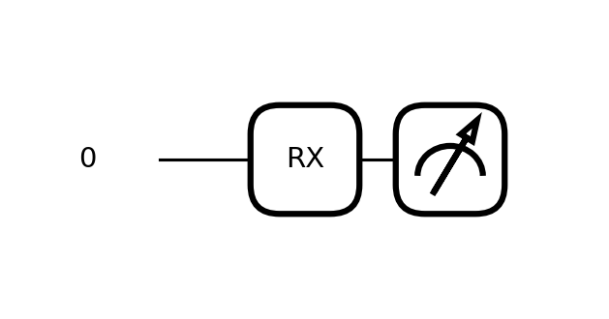
Program 2: Create a single-qubit quantum circuit and apply the Rotation-Y (Ry) gate with a rotation angle of π/3. Display the resulting quantum state and visualize the quantum circuit.
OUTPUT:
Code:
@qml.qnode(dev1)
def prog2(theta):
qml.RY(theta, wires=0)
return qml.state()
theta = np.pi/3
state = prog2(theta)
print(f"theta = pi/3 = {theta:.4f}")
print(f"Resulting state |psi> = {state}")
print(qml.draw(prog2)(theta))
Output:
theta = pi/3 = 1.0472
Resulting state |psi> = [0.8660254+0.j 0.5 +0.j]
0: ──RY(1.05)─┤ State
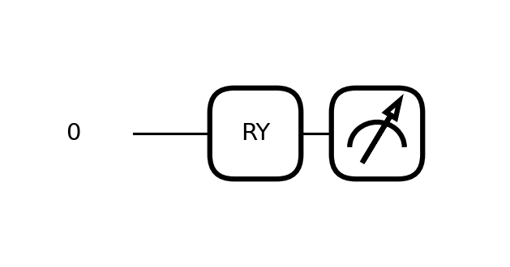
Program 3: Create a single-qubit quantum circuit and apply the Rotation-Z (Rz) gate with a rotation angle of π/2. Display the resulting quantum state and visualize the quantum circuit.
OUTPUT:
Code:
@qml.qnode(dev1)
def prog3(theta):
qml.RZ(theta, wires=0)
return qml.state()
theta = np.pi/2
state = prog3(theta)
print(f"theta = pi/2 = {theta:.4f}")
print(f"Resulting state |psi> = {state}")
print(qml.draw(prog3)(theta))
Output:
theta = pi/2 = 1.5708
Resulting state |psi> = [0.70710678-0.70710678j 0. +0.j ]
0: ──RZ(1.57)─┤ State
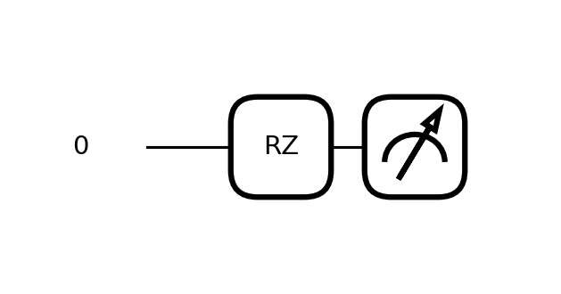
Program 4: Design a single-qubit quantum circuit by applying the Rotation-X (Rx) gate followed by the Rotation-Y (Ry) gate. Display the final quantum state and visualize the quantum circuit.
OUTPUT:
Code:
@qml.qnode(dev1)
def prog4(tx, ty):
qml.RX(tx, wires=0)
qml.RY(ty, wires=0)
return qml.state()
tx, ty = np.pi/4, np.pi/3
state = prog4(tx, ty)
print(f"Rx(pi/4) then Ry(pi/3) -> final state = {state}")
print(qml.draw(prog4)(tx, ty))
Output:
Rx(pi/4) then Ry(pi/3) -> final state = [0.80010315+0.19134172j 0.46193977-0.33141357j]
0: ──RX(0.79)──RY(1.05)─┤ State
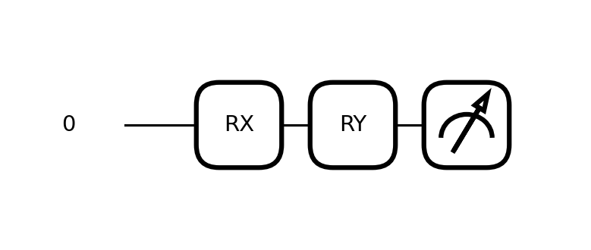
Program 5: Construct a single-qubit quantum circuit by applying the Rotation-X (Rx), Rotation-Y (Ry), and Rotation-Z (Rz) gates sequentially. Display the resulting quantum state and visualize the quantum circuit.
OUTPUT:
Code:
@qml.qnode(dev1)
def prog5(tx, ty, tz):
qml.RX(tx, wires=0)
qml.RY(ty, wires=0)
qml.RZ(tz, wires=0)
return qml.state()
tx, ty, tz = np.pi/4, np.pi/3, np.pi/2
state = prog5(tx, ty, tz)
print(f"Rx(pi/4) -> Ry(pi/3) -> Rz(pi/2) final state = {state}")
print(qml.draw(prog5)(tx, ty, tz))
Output:
Rx(pi/4) -> Ry(pi/3) -> Rz(pi/2) final state = [0.70105738-0.43045933j 0.56098553+0.09229596j]
0: ──RX(0.79)──RY(1.05)──RZ(1.57)─┤ State
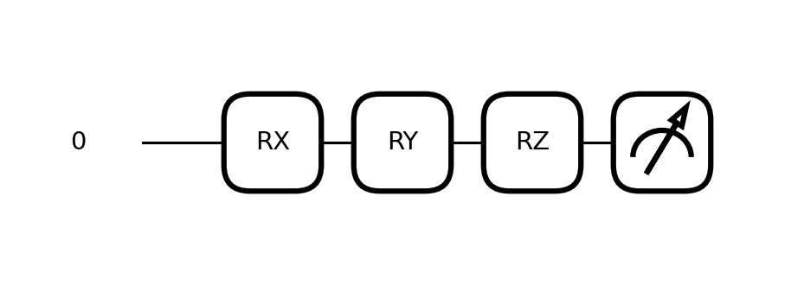
Program 6: Create a single-qubit quantum circuit by applying the Rotation-X (Rx), Rotation-Y (Ry), and Rotation-Z (Rz) gates individually using the same rotation angle (π/4). Display the resulting quantum state for each gate and compare their outputs
OUTPUT:
Code:
theta = np.pi/4
@qml.qnode(dev1)
def prog6_rx(theta):
qml.RX(theta, wires=0); return qml.state()
@qml.qnode(dev1)
def prog6_ry(theta):
qml.RY(theta, wires=0); return qml.state()
@qml.qnode(dev1)
def prog6_rz(theta):
qml.RZ(theta, wires=0); return qml.state()
states6 = {"Rx(pi/4)": prog6_rx(theta), "Ry(pi/4)": prog6_ry(theta), "Rz(pi/4)": prog6_rz(theta)}
for name, s in states6.items():
print(f"{name}: state = {s}, probabilities = {np.round(np.abs(s)**2,4)}")
print("Observation: Rx and Ry both mix |0> and |1> (Rx keeps a complex amplitude, Ry keeps real amplitudes),")
print("while Rz only changes the relative phase and leaves the probabilities unchanged at (1,0).")
Output:
Rx(pi/4): state = [0.92387953+0.j 0. -0.38268343j], probabilities = [0.8536 0.1464]
Ry(pi/4): state = [0.92387953+0.j 0.38268343+0.j], probabilities = [0.8536 0.1464]
Rz(pi/4): state = [0.92387953-0.38268343j 0. +0.j ], probabilities = [1. 0.]
Observation: Rx and Ry both mix |0> and |1> (Rx keeps a complex amplitude, Ry keeps real amplitudes),
while Rz only changes the relative phase and leaves the probabilities unchanged at (1,0).
Program 7: Develop a single-qubit quantum circuit that varies the Rotation-Y (Ry) angle from 0 to 2π. Measure the expectation value of the Pauli-Z operator and plot the graph of expectation value versus rotation angle.
OUTPUT:
Code:
@qml.qnode(dev1)
def prog7(theta):
qml.RY(theta, wires=0)
return qml.expval(qml.PauliZ(0))
angles = np.linspace(0, 2*np.pi, 100)
expvals = [prog7(a) for a in angles]
plt.plot(angles, expvals)
plt.xlabel('Rotation angle theta (radians)'); plt.ylabel('<Z> expectation value')
plt.title('<Z> vs Ry rotation angle'); plt.grid(alpha=0.3); plt.show()
print(f"theta=0 -> <Z> = {prog7(0):.4f}")
print(f"theta=pi/2 -> <Z> = {prog7(np.pi/2):.4f}")
print(f"theta=pi -> <Z> = {prog7(np.pi):.4f}")
print(f"theta=3pi/2 -> <Z> = {prog7(3*np.pi/2):.4f}")
print(f"theta=2pi -> <Z> = {prog7(2*np.pi):.4f}")
print("Observation: <Z> follows cos(theta): starting at +1, dropping to -1 at theta=pi, and returning to +1 at theta=2pi.")
Output:
theta=0 -> <Z> = 1.0000
theta=pi/2 -> <Z> = 0.0000
theta=pi -> <Z> = -1.0000
theta=3pi/2 -> <Z> = -0.0000
theta=2pi -> <Z> = 1.0000
Observation: <Z> follows cos(theta): starting at +1, dropping to -1 at theta=pi, and returning to +1 at theta=2pi.
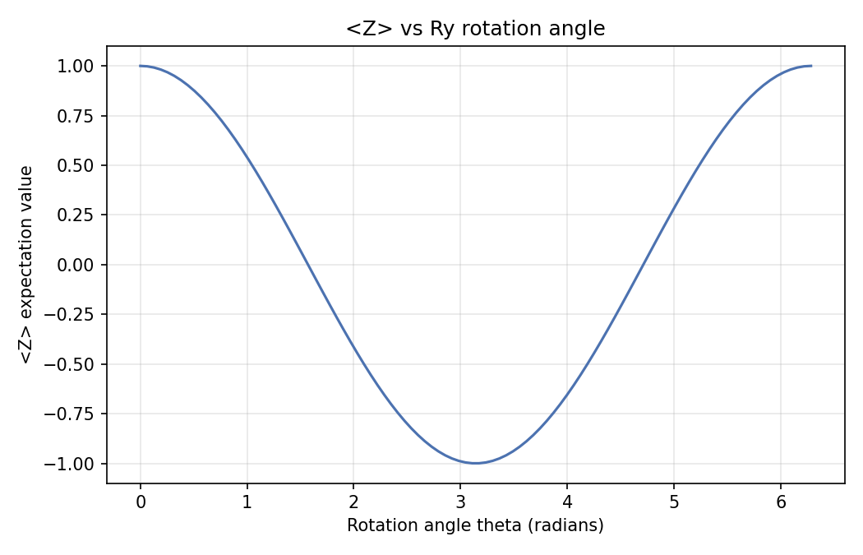
Program 8: Write a PennyLane program to create a single-qubit quantum circuit that applies a Hadamard (H) gate followed by an RX rotation gate with rotation angles (π/6, π/4, π/3). Display the final quantum state and draw the quantum circuit. write a code and program.
OUTPUT:
Code:
@qml.qnode(dev1)
def prog8(theta):
qml.Hadamard(wires=0)
qml.RX(theta, wires=0)
return qml.state()
angles8 = {"pi/6": np.pi/6, "pi/4": np.pi/4, "pi/3": np.pi/3}
for label, theta in angles8.items():
s = prog8(theta)
print(f"H then RX({label}): final state = {s}")
print(qml.draw(prog8)(np.pi/4))
Output:
H then RX(pi/6): final state = [0.6830127-0.1830127j 0.6830127-0.1830127j]
H then RX(pi/4): final state = [0.65328148-0.27059805j 0.65328148-0.27059805j]
H then RX(pi/3): final state = [0.61237244-0.35355339j 0.61237244-0.35355339j]
0: ──H──RX(0.79)─┤ State
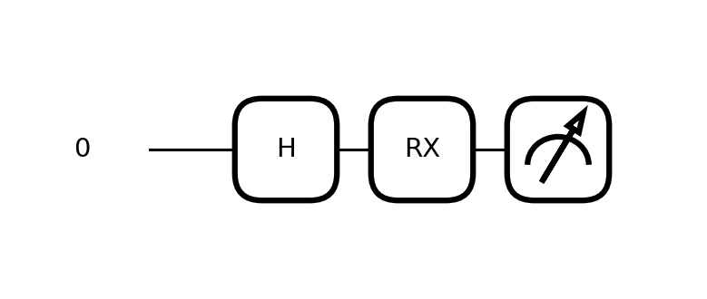
Program 9: Construct a two-qubit quantum circuit by applying the Rotation-X (Rx) gate to the first qubit and the Rotation-Y (Ry) gate to the second qubit. Display the resulting quantum state and visualize the circuit.
OUTPUT:
Code:
@qml.qnode(dev2)
def prog9(tx, ty):
qml.RX(tx, wires=0)
qml.RY(ty, wires=1)
return qml.state()
tx, ty = np.pi/4, np.pi/3
state = prog9(tx, ty)
print(f"Rx(pi/4) on q0, Ry(pi/3) on q1 -> state = {np.round(state,4)}")
print(qml.draw(prog9)(tx, ty))
Output:
Rx(pi/4) on q0, Ry(pi/3) on q1 -> state = [0.8001+0.j 0.4619+0.j 0. -0.3314j 0. -0.1913j]
0: ──RX(0.79)─┤ State
1: ──RY(1.05)─┤ State
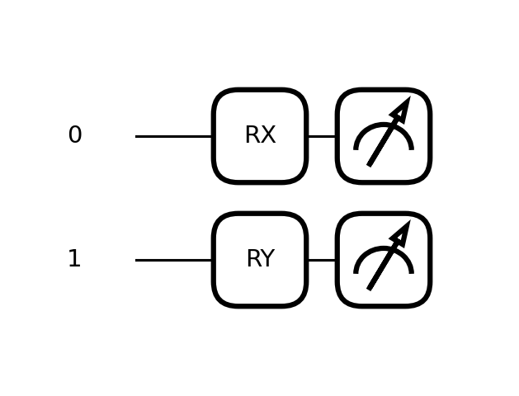
Program 10: Design a two-qubit quantum circuit by applying the Rotation-Y (Ry) gate, followed by a CNOT gate, and then the Rotation-Z (Rz) gate. Display the resulting quantum state and visualize the entangled quantum circuit.
OUTPUT:
Code:
@qml.qnode(dev2)
def prog10(ty, tz):
qml.RY(ty, wires=0)
qml.CNOT(wires=[0, 1])
qml.RZ(tz, wires=1)
return qml.state()
ty, tz = np.pi/3, np.pi/4
state = prog10(ty, tz)
print(f"Ry(pi/3) on q0 -> CNOT(q0,q1) -> Rz(pi/4) on q1 -> state = {np.round(state,4)}")
probs = np.abs(state)**2
print(f"Probabilities |00>,|01>,|10>,|11> = {np.round(probs,4)}")
print(qml.draw(prog10)(ty, tz))
print("Observation: The CNOT entangles the two qubits so the final state cannot be written as a simple")
print("product of two single-qubit states.")
Output:
Ry(pi/3) on q0 -> CNOT(q0,q1) -> Rz(pi/4) on q1 -> state = [0.8001-0.3314j 0. +0.j 0. +0.j 0.4619+0.1913j]
Probabilities |00>,|01>,|10>,|11> = [0.75 0. 0. 0.25]
0: ──RY(1.05)─╭●───────────┤ State
1: ───────────╰X──RZ(0.79)─┤ State
Observation: The CNOT entangles the two qubits so the final state cannot be written as a simple
product of two single-qubit states.
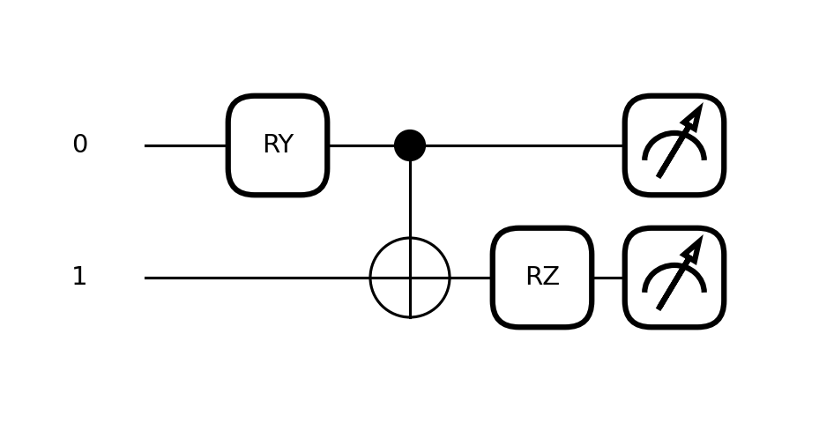
Program 11: Implement a two-qubit Variational Quantum Circuit (VQC) using multiple Rotation-X (Rx), Rotation-Y (Ry), and Rotation-Z (Rz) gates followed by a CNOT gate. Display the final quantum state and visualize the complete parameterized quantum circuit.
OUTPUT:
Code:
@qml.qnode(dev2)
def prog11(params):
qml.RX(params[0], wires=0)
qml.RY(params[1], wires=0)
qml.RZ(params[2], wires=0)
qml.RX(params[3], wires=1)
qml.RY(params[4], wires=1)
qml.RZ(params[5], wires=1)
qml.CNOT(wires=[0, 1])
return qml.state()
params = np.array([np.pi/4, np.pi/3, np.pi/2, np.pi/6, np.pi/5, np.pi/8])
state = prog11(params)
print(f"Parameters (radians) = {np.round(params,4)}")
print(f"Final VQC state = {np.round(state,4)}")
print(f"Probabilities = {np.round(np.abs(state)**2,4)}")
print(qml.draw(prog11)(params))
Output:
Parameters (radians) = [0.7854 1.0472 1.5708 0.5236 0.6283 0.3927]
Final VQC state = [0.5992-0.4652j 0.16 -0.2751j 0.2081-0.0713j 0.5235+0.0281j]
Probabilities = [0.5755 0.1013 0.0484 0.2748]
0: ──RX(0.79)──RY(1.05)──RZ(1.57)─╭●─┤ State
1: ──RX(0.52)──RY(0.63)──RZ(0.39)─╰X─┤ State
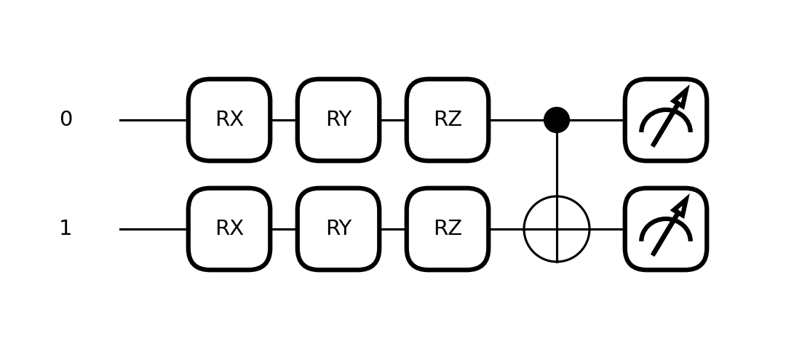
VIVA Q&A:
- What is a parameterized quantum gate?
- What is the purpose of the Rotation-X (Rx) gate?
- What is the purpose of the Rotation-Y (Ry) gate?
- What is the purpose of the Rotation-Z (Rz) gate?
- What is the difference between the Rx, Ry, and Rz gates?
- What is a Bloch sphere, and how are rotation gates represented on it?
- What is the significance of the rotation angle (θ) in Rx, Ry, and Rz gates?
- What is a QNode in PennyLane, and why is it used?
- Why are parameterized rotation gates important in Variational Quantum Circuits (VQCs) and Quantum Machine Learning (QML)?
- How does applying multiple rotation gates sequentially affect the quantum state of a qubit?

RESULT:
Parameterized single-qubit rotation gates (Rx, Ry, Rz) were successfully implemented and simulated using PennyLane. Their individual and combined effects on quantum state evolution, measurement probabilities, and expectation values were studied and visualized, including a full sweep of the Ry rotation angle against the <Z> expectation value. Two-qubit circuits combining rotation gates with a CNOT gate were also constructed to demonstrate entanglement, culminating in a fully parameterized two-qubit Variational Quantum Circuit (VQC). Thus, the study of parameterized rotation gates using PennyLane was carried out and verified successfully.

